Exercise 1: Create a Stored Procedure
QUERY:
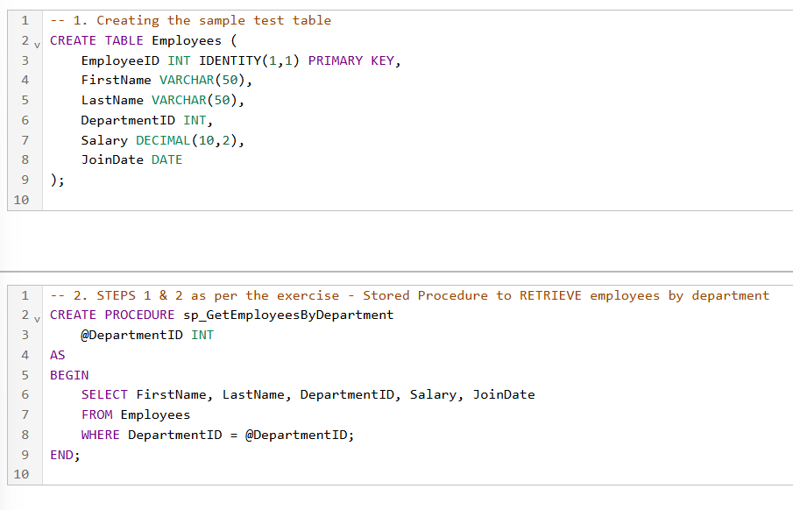
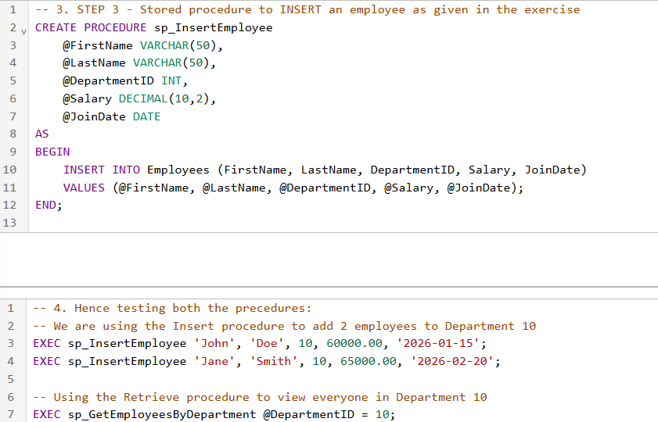

OUTPUT:
